Main
UFO Hypotheses DVD series
Under-Appreciated Science
Productions
Free Subscribtion
Favorites on YouTube
Oldest
2 3 4 5 6 7 8
Newest
Bush Impeachment Inquiry
Special Report
UFO Crash Retrieval Near Aztec
with Wendelle Stevens
Chapter One
Chapter Two
Alex Collier
Volume One
Volume Two NEW
Jim Nichols
Volume One
Michael Schratt
Volume One
Peggy Kane
Volume One
Volume Two
Frequently Given Answers
Events
Recommended Books and DVDs
Special Links NEW
Benevolent E.T. Groups
Contactees and Humanity
Korendor/Bob Renaud
Andromeda/Alex Collier NEW
The Earth and its History
Individuals and Groups
General UFO Evidence
Frontiers of Science
Secret Governement
Violations and Abductions
Systems in Conflict
Malevolent E.T. Groups
email
Contact Under-Appreciated
Science Productions (rick@ufohypotheses.com)

Contactees and Earth Humanity
Contactees
Adamski, George Andreasson-Luca, Betty Angelucci, Orfeo Batallanos brothers Bender, Albert K.
Berlet, Artur Bethurum, Truman Bianca, M.A.O. Burkman, Josefina Butts, Donna
Chacon, Raphael Clark, Kelli Coe, Albert Collier, Alex Creme, Benjamin
Denaerde, Stefan DeWilde, Marius Diaz, Carlos Dibitonto, Giorgio Freitas de Guimares, Prof. Joao
Fry, Dr. Daniel Girvin, Calvin Gonzalez, Oswald Green, Gabriel Hernandez, Prof. R.N.
Herrmann, Bill Hickson, Charles James, Edward Jose y Graciela Kapetanovic, Vlado
Kitano, Keiho Klarer, Elizabeth Kraspedon, Dino Lee, Gloria Maney, Charles A.
Meier, Eduard "Billy" Menger, Howard Miller, Richard Mitchell, Helen & Betty Monsieur "Y"
Onec, Omnec a.k.a. Shiela Schultz (walk-in) Pallman, Ludwig F. Pierceall, Phylliss Reich, Dr. Wilhelm
Renaud, Robert P. Ribera, Antonio Rikenbach, Alois Rincon, Enrique Carlos Rojas-Marcos
Rowe, Kelvin Schmidt, Reinhold Sesma, Prof. Fernando Silva, Chales A. Smith, Dr. Wilbert B.
Souza, Jefferson Stanford, Ray Tomschi, Albert Valerio da Silva, Joao Van Tassel, George
Villa, Apolinar "Paul" Weisengrun, Martin Wells, Sixto Paz White, Edwin Wilcox, Gary
Wilcox, Hal Williamson, George Hunt Wills, Jerry Zanfretta, Fortunato Zirbes, Lloyd
Earth Humanity
"So What Now?" A series of notes by Rick Keefe
Intro Visualize The Present Moment Responsibility Tolerance
Learn of the being-to-being contacts  from the contactees themselves  George Adamski    Back to List  Pastor Albers  Back to List  Betty Andreasson-Luca  Back to List  Orfeo Angelucci  Back to List  The Brothers Batallanos  The North Argentina UFO Contact case of the Batallanos Brothers began in 1996, and is still ongoing. Extra-dimensional beings regularly make demonstrations which the brothers continue to photograph up to present day. The case includes a myriad of photographs taken by the brothers, images which defy all conventional description.  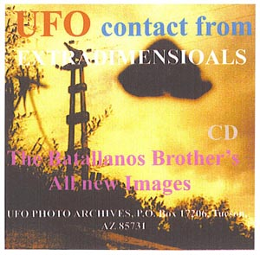  "UFO Contact from Extra-Dimensionals:  The Batallanos Brother's All New Images"  by Wendelle C. Stevens  Back to List  Albert Bender  When a prominent Fifties UFO researcher and his local townspeople find themselves covering and then involved with weird UFO sightings, things become even stranger-than-fiction as Albert Bender, a meticulous investigator into all things metaphysical and UFO-related, finds himself shadowed by three Men In Black ...  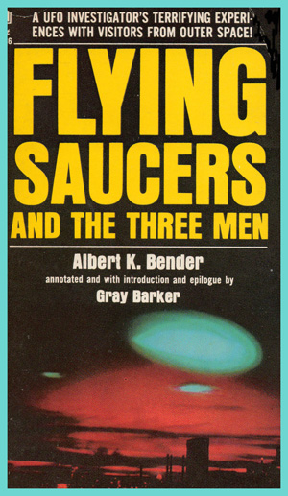  ... (and this is the case that brought this nomenclature to prominence.)  Bender is soon contacted by an extra-terrestrial race which had been operating on Earth for years, harvesting a resource that was finally revealed to Bender, who soon retired, shocking the UFO research field that was just maturing in the Fifties by leaving UFO reporting behind to disappear into a humble, reclusive life with his wife.  Back to List  Artur Berlet  Berlet, a county roads grade driver in Sao Paolo, Brazil, was walking a short cut through fields from his bus stop, when he came upon a landed disc with the occupants out and collecting plants from the field.  Believing him the owner of the field, they abducted him aboard their ship and took off for their home planet called Acart, about the size of Earth with some 20 billion inhabitants, thinking he could help them propogate successfully.  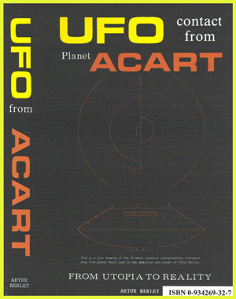  "UFO Contact From Acart:  From Utopia To Reality"  by Artur Berlet  When they discovered on Acart that he knew nothing of such agricultural practices, they apologized for their error and prepared to return him. But, saying that it would take about 2 weeks to get another ship ready, they would treat him as their guest of honor in the interim. He was escorted about the planet observing life there for the waiting time, and he took careful note of their society. Upon return he filled seventeen notebooks with narrative about his observations.  Back to List  Truman Bethurum  Back to List  M.A.O. Bianca  Back to List  Josefina Burkman  Back to List  Donna Butts    Back to List  Raphael Chacon  A printing press repairman in the Tucson, Arizona area was abducted from his small trailer home in Marana and taken elsewhere to view ancient historical sites and operations in the southwest area of the United States.    "UFO Contact From Planet Zeti In Orion"  by Wendelle C. Stevens  The E.T. beings were even unusual compared to the usual descriptions of E.T.s in that these beings appeared to be made up on swirling dots and particles of light that suggested a human form but were not comprised of flesh and bone. The humble contactee, Raphael Chacon, was finally convinved by the E.T.abductors that he was one of them in a previous life incarnation thousands of years ago. The E.T.s finally convinced Chacon to retreat from Earth as they were doing, and so Chacon told his wife and family, who also agreed that Chacon should leave Earth with the E.T.s and rejoin his parent society.  Chacon voluntarily left Earth with the visitors, and so far has never returned.  Back to List  Kelli Clark  Back to List  Albert Coe    Back to List  Alex Collier  Andromedan contactee Alex Collier has had his face-to-face contacts with blue-skinned human ETs from the Andromeda constellation and the Andromeda galaxy, which have included multiple visits aboard their tremendous motherships and decades of telepathic contact. Collier talks of the Andromedan civilization and their Council to which the Pleiadian ETs appealed for assistance in dealing with a dangerous, malevolent ET confederation plaguing humanity and much of the galaxy.  Collier describes in detail the members of this malevolent ET confederation consisting of reptilian ETs from Alpha Draconis, the Orion Group, and the grey ETs from Zeta Reticuli 2, and it appears that the Alpha Draconan reptilian ETs have been manipulating humanity into a nearly invisble system of servitude for aeons, feeding off of our labor and our bodies through the wars that they instigate and the hostile belief systems which they foster in the form of religious and social instituions.  UFO Hypotheses Page devoted to Alex Collier  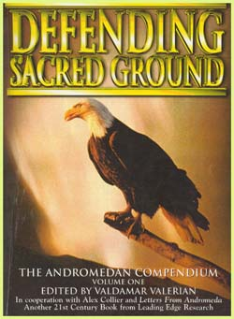  Back to List  Benjamin Creme  Back to List  Stefan Denaerde (a.k.a.    Back to List  Marius DeWilde  The early UFO contact case that involved a French railroad switch operator who suddenly had to deal with a flying saucer that set down squarely on the tracks in his switchyard on his workshift, and how DeWilde handled it. The contact developed as the visitors repeated their visits with DeWilde. An example of a another relatively unknown but worthy contact case from around the world, most of which are just beginning to be shared between citizens of the world.    "UFO Quarouble Contacts of  Marius DeWilde In France"  Back to List  Carlos Diaz    Back to List  Giorgio Dibitonto    Back to List  Prof. Joao Freitas de Guimares  Back to List  Dr. Daniel Fry    Back to List  Calvin Girvin  Back to List  Oswald Gonzalez  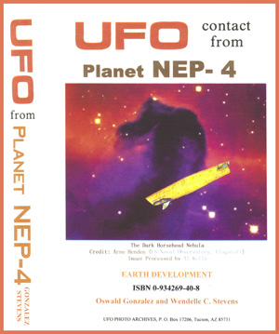  "UFO Contact From Planet Nep-4"  by Oswald Gonzalez and Wendelle C. Stevens.  Mr. Oswald Gonzalez' experiences with alien E.T. beings began in 1936 when he was only five years old, and continued for many years, through the advent of the popular phase of the phenomenon in 1947. By then he was an old-timer, with a number of profound contacts behind him. His late twin brother was also involved in these E.T. contacts, but he has passed on in middle-age.  By age ten, he was making notes on his contacts, and then began keeping a diary of them and his dialogue with those brilliant E.T. humans. He even succeeded in getting photographic proff of the ships himself.  By 1949 he was typing up his contact notes, and filled twelve notebook binders with them. He was an avid researcher and read all he could on the subject. The E.T.s offered new explanations and the true meanins of numerous biblical passages which had been distorted by various translations over the centuries from their original meaning prior to intervention by roman emperors and early roman church leaders. In fact, the E.T.s went so far as to tell the Gonzalez brothers that Jesus Christ did not die on the cross, but instead survived to live out the rest of his life in India and Kashmir.  He was led to Giant Rock, California for a contact on April 12, 1958, and discovered on the following day that others were gathering there for a convention, and he met other interested individuals there for the first time. His contacts with the alien E.T. beings continued until 1972 when events in his life changed for him.  Back to List  Gabriel Green  Back to List  John Harrington  Back to List  Prof. R.N. Hernandez  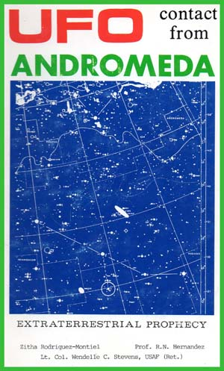  Back to List  William Herrmann  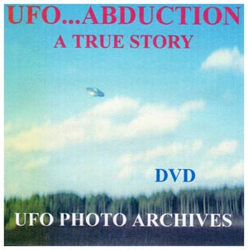  An excellent introduction to the Bill Herrmann UFO contact case is "UFO Abduction: A True Story" which is a sobering, early Eighties classic UFO documentary, co-produced by Jun-Ichi Yaoi of Nippon Television in Japan and Wendelle Stevens that demonstrates the enormous evidence surrounding the contact case of William Herrmann, an inquisitive young man from South Carolina who finds himself caught between contact with extra-terrestrials from Reticulum and the opposing forces from his fundamentalist church.  Herrmann aslo suffered insidious attacks by a mysterious group of government operatives whose purpose appears to be to frustrate both himself and the team of UFO researchers who were investigating Herrmann's multi-year contact case.  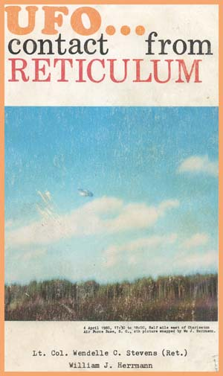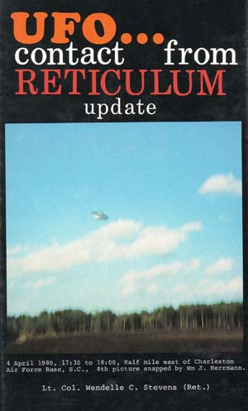  Back to List  Charles Hickson  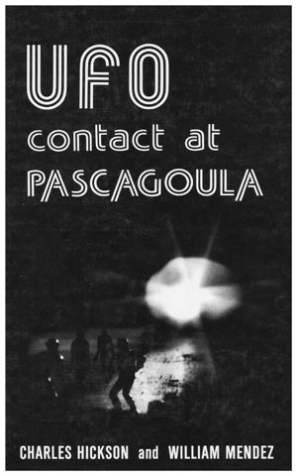  Back to List  Edward James    Back to List  Jose and Graciela, Aymara Indians  Jose, from southwest Ecuador, was approached near a river by a being from a landing flying disc. The extra-terrestrial being from Planet Ectom asked Jose if he and his wife Graciela would be willing to carry one of the fertilized ovums of the E.T.s through the early development of the embryo. The goal of the Ectom E.T.s was to impart Earth humanity's emotional sensitivity into their species, which had all but lost their emotions over the aeons. Thr Ectom E.T.s hoped that this experimental process would help them be successful in regaining the emotions they had lost over the generations. There were eight other native women involved in this impregnation process in this region of Ecuador at the same time.    Back to List  Vlado Kapetanovic  Alien ET visitors contacted hydro-electric plant engineer Vlado Kapetanovic in Peru at the power generating station. They met him several times on the high Altiplano mountain range after that. They were treating native Altiplanos who had no access to medical treatment. The ETs demonstrated remarkable cures aboard their vehicles.    "UFO Contact From Planet Apu"  by Vlado Kapetanovic and Wendelle C. Stevens  They had one-piece suits that allowed them to fly independently like birds. The ETs showed him many ancient historical events from Peru's' ancient past, including how blocks were carved and flown into position in the great Peruvian megalithic structures.  Back to List  Elizabeth Klarer  Back to List  Dino Kraspedon (a.k.a. Aladino Felix)  Back to List  Keiho Kitano    Back to List  Gloria Lee  Back to List  Charles A. Maney  Back to List  Eduard "Billy" Meier  Eduard "Billy" Meier, a one-armed farmer from humble means has been able to take the clearest, most detailed photographs and movie footage of flying saucers in public hands in known history.  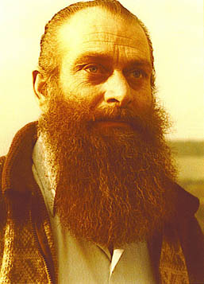  Eduard "Billy" Meier  A Challenge to Modern Science, Economics and Religion  As a young man, Eduard "Billy" Meier began experiencing contacts with a female cosmonaut, named Asket, who said that she came from what she called the DAL Universe, a counterpart universe to ours, and the reason for which we exist.  Asket led Meier through all of the world's great religins, and Meier became a lay teacher of each, in preparation for his future role in disseminating Pleiadian understanding to Earth humanity. Asket took Meier to the very doors of death on a number of occasions to prepare him for his future role with visitors from the Pleiades.  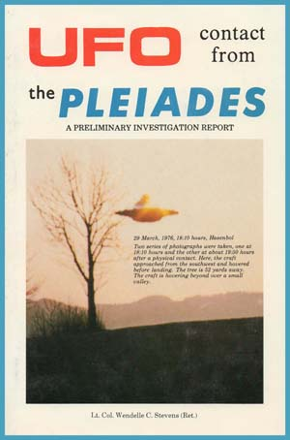  "UFO Contact From The Pleiades:  A Preliminary Report"  by Wendelle C. Stevens  Meier is probably the world's most famous contactee, having shared with the world over forty years on ongoing contact dialogue, photographs, film footage, and information transmitted to Meier by this race of E.T. beings.  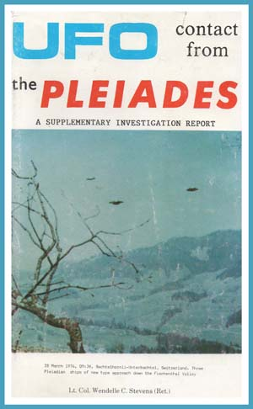  "UFO Contact From The Pleiades:  A Supplementary Report"  by Wendelle C. Stevens  Meier even claims to have numerous opportunities to travel the galaxy with these human E.T.s from planets around the star Teygeta in the Pleiades Constellation who apparently remain in contact with Meier even to this day.  "More about Meier" from ANGELFIRE.COM  A Tour of Meier's Photo Album narrated by Randy Winters  A Billy Meier Interview by FIGU 1988-November-20th  A Cautionary Note:  There also appears to be a great deal of commercialization of so-called Pleiadian information via various channelers, as well as capitalization of the Pleiadian name and Meier's FIGU organization by individuals with a profit and ego motive. Beware. Alternately, there is an abundance of skeptics' dis-information and debunking out there as well. Beware.  Back to List  Howard Menger  Menger's Official Website  Back to List  Richard Miller    Back to List  Helen and Betty Mitchell  The autobiographical report of the Mitchell Sisters' contacts, contemporary with the early contactees such as Adamski, Rowe, Angelucci, Menger, Bethrum, and so forth. The Mitchell Sisters, Helen and Betty, describe in detail their experiences with two male ETs who told the sisters that they came from the planet Mars, and demonstrated this to their satisfaction. These contacts were occuring in 1957, and continued regularly for a number of years after that.    UFO Contact From Mars: Among The Saucers:  The Autobiography of the Mitchell Sisters  by Helen and Betty Mitchell (Authors),  Wendelle C. Stevens (Editor, Introduction, Preface)  UFO Contact Series [E-Book CD] Volume 1  Back to List  Monsieur "Y"  The Baavian E.T.s have made contact with humans a number of times throughout the ages, and in 1964 they took Monsieur "Y" from the Algerian desert to their home planet Baavi for two months, where he worked and lived among them. "Y" returned to Earth with texts of their language, mathematics, sciences, systems of weights and measures, and their philosophy, and these texts remain secretly hidden in a French language university, withheld from public scrutiny. Those language scholars who have studied the Baavi language brought back by "Y" have stated that it bears all the characteristics of a useful language system, and also state that it is unlikely that "Y" or anyone else contrived the language here on Earth.  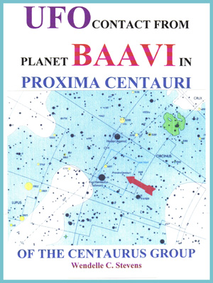  "UFO Contact From Planet Baavi  In Proxima Centauri of the Centaurus Group"  by Wendelle C. Stevens  "Y" had a dozen notebooks filled from his trip to Baavi, which orbits with several cold planets around the Proxima Centauri star in the constellation of Centaurus, 4.3 light years from our own sun, which is very close in relative terms to the rest of the galaxy.  Back to List  Omnec Onec a.k.a. Sheila Schultz  a "walk-in"  "UFO: From Venus I Came"  an autobiography by Omnec Onec,  a.k.a. Shiela Schultz.  This is the UFO contact case of a beautiful hairdresser who claimed that she was a walk-in extra-terrestrial from Venus. "From Venus I Came" is Omnec's history of her life on Venus, and the events of her life that continued on Earth after re-inhabiting the body of a young girl who had just been killed in a freak bus accident that was foreseen by her elders on Venus. Her "walking-in" was for purposes explained in this stunning and controversial account.  Back to List  Ludwig F. Pallman  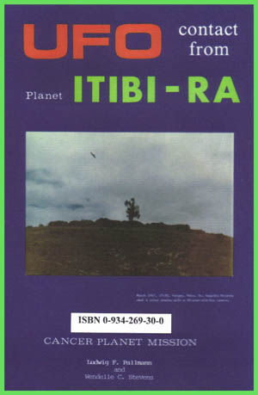  Back to List  Phylliss Pierceall  "UFO Contact From Beyond Rigel," by Lucius Farish, Wendelle C. Stevens, and Phyl Pierceall. An ethnic Cherokee Indian girl and her mother were sitting on a fallen tree trunk watching the sunset when a moving brilliant pulsating light approached from beyond the treeline directly in front of them and hovered a couple hundred feet away.    Phyl, the nineteen-year-old daughter, jumped off the log and ran toward the object. As she did so a container descended from it directly in front of her and touched down on the grass. A being came from it and put a pancho-like cover over her and took her aboard the craft with him. That began a series of ongoing experiences with those "green-skinned" ETs who told her that they came from beyond Rigel.  Back to List  Dr. WilhelmReich  Back to List  Robert P. Renaud  A young high school graduate, Robert P. "Bob" Renaud, living in his parent's basement and working for General Electric in a radio assembly plant back in the 1950s, built his own radio and television sets from kits, and then encountered strange transmissions which spoke to him directly, and told him how to modify his radio set for better reception. Then, the ETs did the same thing with his home-built television kit, and he was soon able to receive their visually transmitted messages.  These communications evolved into face-to-face contacts on a regular and frequent basis until Renaud was taken to view their Moonbase on the Earth's Moon, and the Korendian underground operations base under Massachusetts. He was also taken to their underwater operations base in the South Pacific.  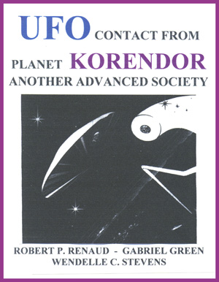  "UFO Contact From Planet Korendor:  Another Advanced Society: Volume One"  by Robert P. Renaud,  Gabriel Green, and Wendelle C. Stevens.    "UFO Contact From Planet Korendor:  Another Advanced Society: Volume Two"  by Robert P. Renaud and Wendelle C. Stevens  Bob Renaud's personal contacts with alien E.T.s from a planet they call Korendor resulted in his regularly going aboard their craft, and to their Korendian facilities in our Earth's vicinity. Renaud was, in fact, the first Earth man to "walk in space" when he stood on top of one of their expeditionary craft with his escort looking back at the Earth below them on February 4, 1964.  He was eventually taken to their home planet of Korendor, where he discovered that their animals roamed free and unrestrained, and that none of the animals had become predators as on Earth. His contacts are still ongoing to this time, and at last count, over three hundred Korendians, who are humans, have integrated into various levels of Earth society to help bring benevolent, peaceful evolvement of Earth humanity. Korendians are in a number of government positions, guiding thoughts towards more benevolent pursuits.  The Korendor webpage  Back to List  Antonio Ribera  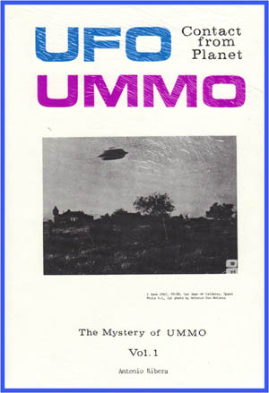  Back to List  Alois Rikenbach  Back to List  Enrique Carlos Rincon  Back to List  Rojas-Marcos  Back to List  Kelvin Rowe  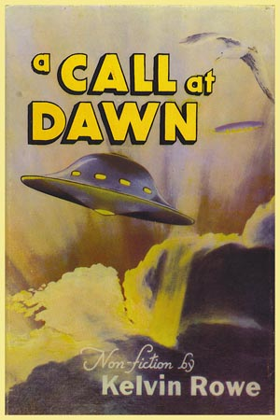  Back to List  Reinhold Schmidt  Back to List  Prof. Fernando Sesma-Manzano    Back to List  Charles A. Silva  Back to List  Dr. Wilbert B. Smith  Back to List  Jefferson Souza  Back to List  Ray Stanford    Back to List  Albert Tomschi  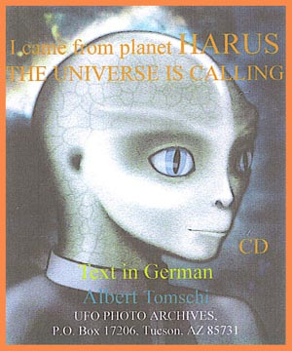  Back to List  Joao Valerio da Silva  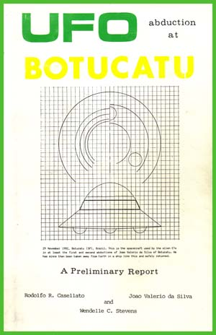  Back to List  George Van Tassel  Back to List  Apolinar "Paul" Villa  Paul Villa, of American Indian and Spanish descent, was a World War II veteran who brought his German bride back to America. He was first contacted in California by tall extra-terrestrial human beings who explained that they came from Coma Berenesis.    The E.T.s spoke to Villa in Spanish (Villa's native language), and also spoke fluently in English with him as well. The E.T.s explained to Villa that they had been visitng Earth for many ages, and demonstrated that they knew Earth civilizations very well. They told Paul that they had bases on the Moon, Mars and Venus from which to monitor Earth humanity. Like the Meier case in Switzerland, these E.T.s were willing to pose their ships to allow the "contactee" Villa to photograph them well. One series of photos was filmed on another planet, but has not been revealed to the public.  Back to List  Martin Weisengrun  a.k.a. Andreas Henisch    Back to List  Sixto Paz Wells  Back to List  Edwin White  A graduate student in an alien space academy on the planet Koldas, required to live and support himself for two years on an extra-planetary body, chose Earth for his post-graduate assignment because his instructor in the ET academy had also chosen Earth for his assignment. The instructor's glowing accounts of the extreme variety in all species and classes of things on Earth fascinated the young ET student, particularly our institutions of religion and money, which their ET society did not have. In his work assignment to support himself here, the young ET from Koldas worked at an electronics assembly plant with Edwin White. The two humans became good friends as White took the ET to various churches at the ET's particular request. When the ET finished his assignment and was picked up by his planetary society, he had helped White modify his ham radio set so that the ET could make direct contact with White at any time. The ET explained Koldas' interest in their operations here on Earth.    UFO CONTACT FROM PLANET KOLDAS:  A COSMIC DIALOGUE  by Carl van Vlierden and Wendelle C. Stevens (Authors),  Wendelle C. Stevens (Editor, Introduction, Preface)  UFO Contact Series [E-Book CD] Volume 27  Back to List  GaryWilcox  Back to List  Hal Wilcox  Back to List  George HuntWilliamson  Back to List  Jerry Wills  Back to List  Fortunato Zanfretta    Back to List  Lloyd Zirbes  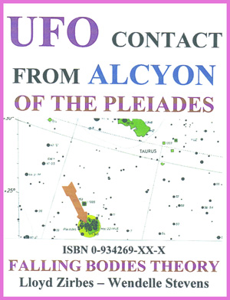  "UFO Contact From Alcyon of the Pleiades"  by Lloyd Zirbes and Wendelle C. Stevens  A Minnesota farmer, checking his trap lines, is abducted on his way home at night, an taken aboard an alien vehicle, along with a neighboring family, who were already aboard. The farmer, Lloyd Zirbes, was shown on viewing screens the deficiencies in our understanding of physics, and also shown the forces behind all motion and creation. The "Falling Bodies Theory" demonstrated is so profound that Zirbes had to begin taking college-level physics courses in order to understand the Alcyon E.T.s' theories. Zirbes has now become a professor of physics, and offers the alien's "Falling Bodies Theory" concepts to academia. The Zirbes case is also noteable in that it is another valid case of UFO Contact from the Pleiades star cluster, demonstrating again that the Pleiades is an area of our galaxy from where a number of ET contacts on Earth are originating.  Back to List | So What Now?  A series of notes  by Rick Keefe  June 26 , 2008 Our Society Sucks, So Now What? (Intro)  Once you have stepped back and taken an unbiased look at America and what its average citizens get in the form of government, well-being, wages versus cost of living, and standard of living, it is plain to see that the last twenty eight years of government has failed us. The upper 1% elite rich appear to have strangled the 99% below through crooked elections, taxes that they collect and then funnel into their ultra-wealthy empires, and the deconstruction of the original Constitution and the Bill of Rights.  Our society sucks, so now what?  This is exactly what Thomas Jefferson warned Americans about two hundred years ago, when he said in a letter to John Taylor, "I sincerely believe with you that banking establishments are more dangerous than standing armies."  Jefferson also said, "A little revolution now and then is a good thing."  Well, short of revolution, what can we begin to do on an individual and grass roots basis to change our society for the better, and improve our way of life, despite the current government of our lives by elite banking and oil families?  That will be the essence of the essays on UFOHypotheses.com for the next several months to come. Stay tuned...  June 29, 2008 So Now What? Part 1  Visualize A Good World  and A Good Self  If we want to live in a better world, we first have to practice visualizing that particular good world, which we will fill with our good actions.  Thoughts come in all varieties, but how you act on your thoughts determines the reality of the world that we share together. So in order to create a better world, you need to start with yourself, and practice acting and making decisions-- especially little, everyday decisions-- based on an awareness that you have.  One needs to consciously, constantly reevaluate your thoughts, look at them from different perspectives, and view your desires objectively, making every effort to see the ripple effects of what happens when you behave acting on any of your thoughts. Act on your thoughts with the highest good in mind, and reject acting on your poor, selfish, strictly self-serving thoughts.  This is fundamnetal in creating a good world.  July 4, 2008 So Now What? Part 2  The Present Is Your Point of Power  If we want to make the best use of our own free will, we need to remember that the present moment is our point of power.  One of the most influential books for me has been a book recommended to me by a guitarist friend in Tucson. This book had such a profound effect upon my ways of thinking that I can not express it enough. One of the tenets of the book that I am always practicing is the discipline to understand that the present moment is our point of power.  "THE PRESENT ISTHE POINT OF POWER. The above is one of the most important sentences in this book in practical terms, and working within the framework of time as you understand it (pg. 307)... Those of you who believe in reincarnation in more or less conventional terms, can make the error of using or blaming "past" lives, organizing them through your current beliefs. It is bad enough to believe that you are at the mercy of one past, but to consider yourself helpless before innumerable previous errors from other lives puts you in an impossible situation; the conscious will is robbed of its power to act. Such lives exist simultaneously. They are other expressions of yourself, interacting, but with each conscious self possessing the point of power in its own present... In whatever framework you choose, you will always find proper reinforcement for your belief. The truth as far as it can be stated is this: YOU FORM YOUR REALITY NOW, in capital letters, through the intersection of soul in flesh, and in your terms the present is your point of power."  Seth,  channelled through Jane Roberts,  recorded by her husband, Robert Butts    July 5, 2008 So Now What? Part 3  Choosing Responsibility  When I was a sophomore in college, and was studying to become a filmmaker, there was an afternoon when I was reading a Rolling Stone interview of a famous, blockbuster filmmaker, and I became angry that this director had made a film that induced a huge amount of terror into society. I decided that I would be very careful about the films I made, and the projects that I would become involved with because I wanted to be a responsible person. I had been reading about cosmic concepts like karma, and I felt that Film in today's society was such a powerful medium and mechanism. I did not want to use Film for personal gain at the expense of other people's welfare. That's all. I just chose responsibility, and acted on it, putting my desire to be responsible into action. That decision steered me away from being involved in many projects, and I am glad for it, because now I don't have to clean up after what would have been mistakes of judgement.  A friend of mine, Alex Collier, who also claims to be a contactee with beings from Andromeda, received some advice for humanity with regard to responsibility. The short, bluish-white skinned 4300-year-old sage named Vissaeus from the Andromedan society who was mentoring Alex shared this philosophy after Alex had queried him about Earth humanity's destiny:  "Responsible freedom of self-determination. Becoming truly self-confident and free to unconditionally be responsible for one's self, without being coerced to accept some higher authority."  Vissaeus of Andromeda  "Defending Sacred Ground" pg. 70  July 10, 2008 So Now What? Part 4  Tolerance  I have never understood the ugliness of emotional states one must be in to ever ridicule someone about the color of their skin, their sexual orientation, their religion or lack thereof, their nationality, or for their lack of wealth.  To me it is as simple as this: when you discriminate in these ways, you eliminate many potential friends, contributors, trusted colleagues, heroes in a desperate moment, human beings that would contribute great benefit and joy to your life, and you crush your universe into a smaller and smaller box of retardation.  I think I need to work on my tolerance of the intolerant.  Well, as Joe E. Brown exclaimed at the end of "Some Like It Hot":  "Nobody's Perfect!"    Dec 27, 2008 So Now What? Part 5  Consciousness and Benevolence  I was responding to some remarks and graffiti on my semi-annual editing of YouTube comments on the UFOHypotheses site, and I wrote back a reply on one page in Peggy Kane Vol. 2 "NASA Upside Down" that I rather liked just as soon as I had written it:  "There's a sentiment in this statement, although religious, that I can get behind, and that is , in my interpretation, that we are all aspects of God, made physical in the third dimension, but retaining consciousness, which to me feels like the greatest gift from the good heart of, I guess, the universe and whatever that might be."
Main  UFO Hypotheses DVD series  Under-Appreciated Science Productions  Events  Special Links  Raw Research,  Index and Glossary  Benevolent E.T. Groups  Contactees and Humanity  The Earth and its History  Individuals and Groups  General UFO Evidence  Frontiers of Science  Secret Governement  Violations and Abductions  Systems in Conflict  Malevolent E.T. Groups  This page designed by Rick Keefe (c)2006-2007 Rick Keefe. All rights reserved.  Specific copyrighted content, images and links are the property of their original owners. | Main  UFO Hypotheses DVD series  Under-Appreciated Science Productions  Events  Special Links  Raw Research,  Index and Glossary  Benevolent E.T. Groups  Contactees and Humanity  The Earth and its History  Individuals and Groups  General UFO Evidence  Frontiers of Science  Secret Governement  Violations and Abductions  Systems in Conflict  Malevolent E.T. Groups  This page designed by Rick Keefe (c)2006-2007 Rick Keefe. All rights reserved. Specific copyrighted content, images and links are the property of their original owners.

